Aurtumn 2000

Class II Information Technology Engineer Examination - Afternoon
Class II Information Technology Engineer Examination (Afternoon)
Questions must be answered in accordance with the following:
Question Nos. | Q1, Q2 | Q3 - Q6 | Q7 - Q10 | Q11 - Q14 | Q15 - Q17
Question Selection | Compulsory | Select 2 of 4 | Select 1 of 4 | Select 1 of 4 | Select 1 of 3
Examination Time | 13:00 ~ 15:30 150 minutes
Instructions:
1. Use an HB pencil.
If you need to change an answer, erase your previous answer completely and neatly. Wipe away any eraser debris.

2. Mark your answers in accordance with the instructions below. Your answers will not be graded if you fail to comply with the instructions. Do not mark or write on the answer sheet outside of the prescribed places.
(1) Examinee Number
Write your examinee number in the space provided, and mark the appropriate space below each digit.
(2) Date of Birth
Write your date of birth (in numbers) exactly as it is printed on your examination admission card, and mark the appropriate space below each digit.
(3) Question Selection
How to Mark Your Answers
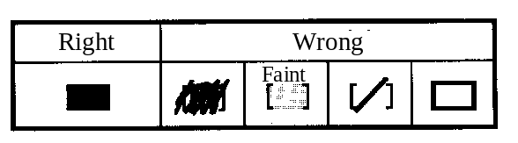
Mark the [ ] of the questions that you select to answer.
(4) Answers
Mark your answer as shown in the following sample question:

[Sample Question] Select the correct answer to be inserted into the correcponding box ( ) from the choices provided below.
The Fall Information Technology Engineer Examination is held in a .
Answer group for a:
a) October b) November c) December
Since the correct answer is "A" (October), mark your answer sheet as follows:
[Sample Reply]
a | a) | b) | c)

3. Assembler specifications are provided as a reference at the end of this booklet. The information provided on page 70 and beyond, however, is only intended for use with Q17.

Do not open the exam booklet until instructed to do so. Inquiries about the exam questions will not be answered.

